The following details need to be included in the HOME tab,
Our exceptional experimental and technological capabilities allow us to innovate new frontiers in optics and photonics. Some of our expertise is listed below as follows:
Generating structured laser sources at Infrared, visible, UV, and deep UV wavelengths (description and images)
High-quality diffractive optics for high-power and lossless beam shaping (description and images)
Surface processing and structuring with vortex and vector light beams (description and images)
Laser drilling, cutting, and scribing with non-diffracting laser beams (description and images)
High-resolution imaging: problems and solutions (description and images)
XUV metrology and XUV imaging using structured light beams (description and images)
Lower-order and Higher-order harmonic generation driven by classical and quantum light.
(description and images)

The following details need to be included in the About tab,
Our mission:
At our lab, we advance laser and optics technology to promote innovation and design, enabling groundbreaking research with classical and quantum light for advanced applications and highly sought-after scientific studies.
Innovation:
At our Quantlight & High Harmonics Lab, we continually incorporate the latest advancements and solutions into the development of laser sources and diffractive optics capable of operating across multiple spectral ranges. Our efforts leverage versatile, efficient materials, optical technologies, and diffractive optics to drive technological innovation.
Quality:
Our Lab is committed to delivering laser technology, diffractive optical elements, and optical solutions of the utmost quality and precision to meet the needs of scientific and engineering applications.
Performance:
Our diffractive optical elements and laser technology are engineered for high quality and superior performance in classical and quantum optics, as well as photonics experiments and applications. We are excited about our diffractive optics, which have great potential for laser processing, optical communication, micromachining, microfabrication, and high-resolution imaging, supported by ongoing research.

Leadership

Our leadership and team work with great commitment and passion to explore the frontiers of laser, photonics, and quantum technologies. Our scientists and engineers collaborate to develop innovative optics and laser technologies that deliver tangible results and demonstrate potential applications. Every research project and product development we pursue brings us closer to a highly productive era in optics and quantum technologies, accelerated by our dedication and scientific expertise, thereby meeting requirements and ensuring customer satisfaction across industry and academia.

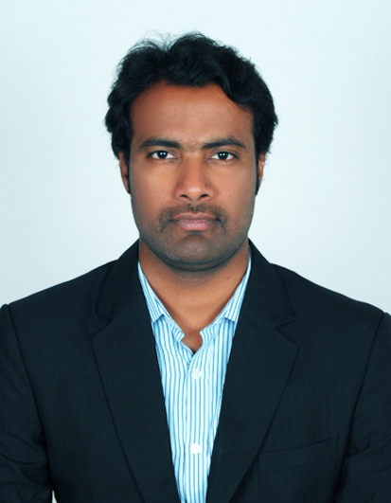
Dr. A. Naresh Kumar Reddy
Founder & Director (Research & Technology, Operations)
Team Lead, developing advanced laser technology for industrial and medical applications.
Research interests: Light-matter interactions, Beam shaping elements and technologies, High-harmonic generation & applications, Structured light pulses, Laser material processing (cutting, drilling, surface structuring), Additive manufacturing, Metalens, High-resolution imaging
Work experience: 15 years

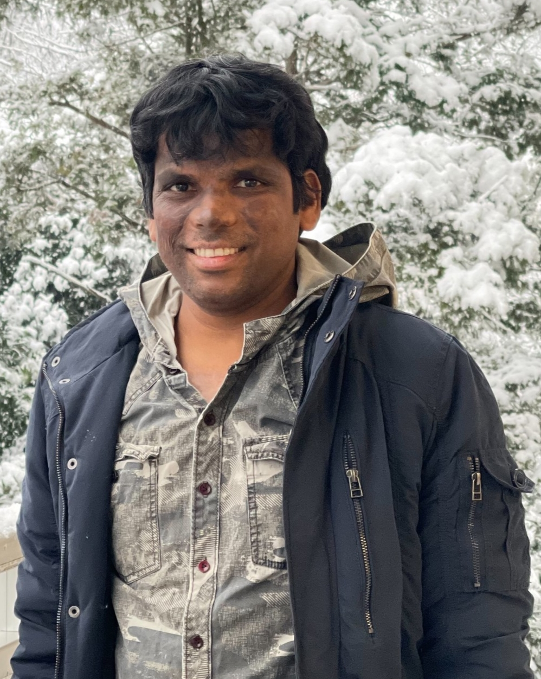

Dr. Srinivasa Rao Allam
Senior Scientist, Laser Engineering
Team Lead, developing high-power ultraviolet light sources for light-matter interactions.
Research interests: Light-Matter interactions, Laser Cavities, Nonlinear Optics,
Structured laser sources, Optical Skyrmions, and Bio-photonics
Work experience: 12 years

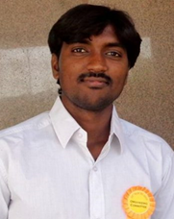

Dr. Naresh Kedam
Senior Engineer, Computational Optics
Research Interests: Aerospace technologies, Computational modeling, Machine learning, and AI-driven solutions for lasers and optics.
Work experience: 8 years

Research Advisers & Collaborators

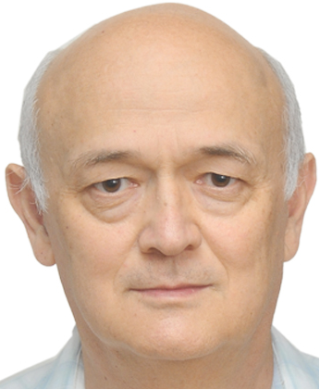

Prof. Rashid A. Ganeev
Chief Researcher
Laboratory of Materials Science, Laser and Nanotechnology
Institute for Advanced Studies
New Uzbekistan University, Movarounnahr 1,
Tashkent 100007, Uzbekistan
Research interests: Nonlinear Optics, High-harmonic generation

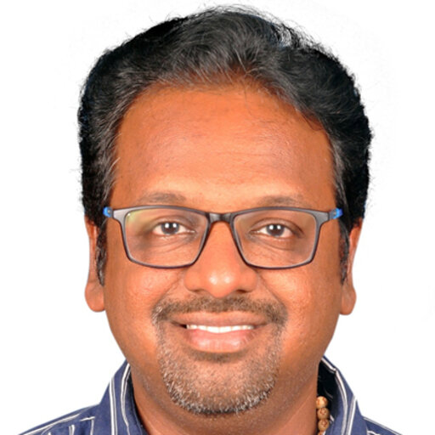

Prof. Vijayakumar Anand
ERA CIPHR Chair
Group leader, Computational imaging and processing with high-resolution
Institute of Physics, University of Tartu,
W. Ostwaldi, 50411 Tartu, Estonia.
Research interests: Incoherent imaging, Digital holography, Diffractive optics, and micro/nanofabrication

Corrections needed on the page quantlight.netlify.app
- Please keep the contact number 9866802424, and remove the other number.
- Keep both email IDs and the contact number inside the Contact tab.
- Please remove the Blog tab from the home page.
- Please replace 17+ years of Excellence in advanced photonics research with 10+ years of Excellence in advanced photonics and lasers research.
- Please use the following statements for the title description.
“Pioneering research focuses on the implications and advancement of classical and quantum structured light, uncovering how such light fields are involved in both scientific and industrial applications. It also encompasses creating ultrashort laser pulses at shorter wavelengths via high-harmonic generation or nonlinear light-matter interactions, opening possibilities and applications including EUV imaging, EUV lithography, EUV metrology, nanofabrication, coherent diffractive imaging, and shaping attosecond pulses.”
- Please remove our awards and achievements section from this page.
- I have already shown our expertise under the company title description (point number 5), and no need to show a separate paragraph of our expertise with a label (“Pioneering Structured Light and High-Harmonic Research”). Therefore, please remove those details from this page.
- “Our offices”- Office 1 replaced by the “Registered Office” and Office 2 replaced by the “QuantLight Lab”, their addresses as follows,
Registered Office:
Street No. 16, Nalanda Nagar,
Hyderguda, Rajendra Nagar, Hyderabad-500048
e-mail: naarereddy@gmail.com, optics.spectroscopy@gmail.com
QuantLight lab:
Street No. 16, Nalanda Nagar,
Hyderguda, Rajendra Nagar, Hyderabad-500048
e-mail: quantlightlab@gmail.com
- We need to have a separate tab for including the list of publications along with their title and DOI links so that if someone clicks the link, it will direct to the publication webpage that belongs to the journal.
- In the Home page, there is a space between the top and the bottom of the page that we need to avoid. The home page should be more informative and should grab the attention of visitors, which leads to creating a special interest in the company profile.
- We also need to show some experimental pictures that were obtained from the articles published with the company name affiliation.
- Finally, I will share photographs corresponding to various laser setups and optical arrangements that establish the laboratory infrastructure of the company. It is necessary to keep those photographs on the website that will bring more exposure to the company.

After making the above changes and corrections, I believe the website's final appearance will be more elegant and dynamic.

